HDL00100 – Pricelist Lookup

USER INTERFACE

INITIAL VERSION
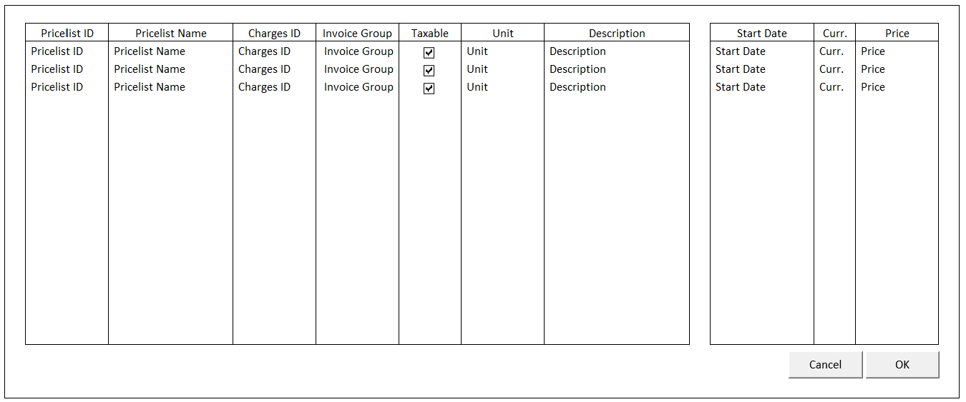

BUTTON DEFINITION
Button Name | Action
Cancel | Jalankan CANCEL PROCESS
OK | Jalankan PROCESS

INPUT PARAMETER
Parameter Name | Description
CCOMPANY_ID | Company Id
CPROPERTY_ID | Property Id
CTAXABLE | 0 – All, 1 – Taxable, 2 – Non Taxable
CUSER_ID | User Id

OUTPUT PARAMETER
Parameter Name | Description
CCOMPANY_ID | Company Id
CPROPERTY_ID | Property Id
CPRICELIST_ID | Pricelist Id
CPRICELIST_NAME | Pricelist Name
CCHARGES_ID | Charges Id
CUNIT | Unit
CDESCRIPTION | Description
CACTIVE_START_DATE | Active Start Date
CINVGRP_CODE | Invoice Group
LTAXABLE | Taxable

INITIAL PROCESS
Test
- Load data from Input Parameter
- Set VAR_COMPANY_ID = Login User’s company id
- Set VAR_USER_ID = Login User ID
- Set VAR_LANGUAGE_ID = Login User’s Language ID
- Set VAR_STATUS = ‘0’

- Load Pricelist List
Jalankan RSP_HD_GET_PRICELIST_HEADER_LIST dengan parameter, simpan hasil ke VAR_PRICELIST_HEADER_LIST dan VAR_SELECTED_PRICELIST HEADER
  - VAR_COMPANY_ID
  - CPROPERTY_ID
  - CTAXABLE
  - VAR_LANGUAGE_ID

- Load Pricelist Detail
Jalankan RSP_HD_GET_PRICELIST_LIST dengan parameter, simpan hasil ke VAR_PRICELIST_LIST:
  - VAR_COMPANY_ID
  - CPROPERTY_ID
  - VAR_STATUS
  - VAR_LANGUAGE_ID
  - VAR_SELECTED_PRICELIST_HEADER.CPRICELIST_ID

DISPLAY PROCESS

FIELD DEFINITION
Name | Field | Type | Validation
Pricelist Header Grid |  | Data: VAR_PRICELIST_HEADER_LIST | Allow: -  ViewOnly  On Selected Changed,  Set VAR_SELECTED_PRICELIST_HEADER = Selected row data  Load Pricelist Detail  Jalankan RSP_HD_GET_PRICELIST_LIST dengan parameter:  - VAR_COMPANY_ID  - CPROPERTY_ID  - VAR_STATUS  - VAR_LANGUAGE_ID  - VAR_SELECTED_PRICELIST_HEADER.  CPRICELIST_ID
Pricelist ID | CPRICELIST_ID | Textbox, Disabled
Pricelist Name | CPRICELIST_NAME | Textbox, Disabled
Charges ID | CCHARGES_ID | Textbox, Disabled
Invoice Group | CINVGRP_CODE | Textbox, Disabled
Taxable | LTAXABLE | Checkbox, Disabled
Unit | CUNIT | Textbox, Disabled
Description | CDESCRIPTION | Textbox, Disabled
Active Start Date | CACTIVE_START_DATE | Hidden
Pricelist Detail Grid |  | Data: VAR_PRICELIST_LIST | Allow: -  ViewOnly
Start Date | CSTART_DATE  Set DSTART_DATE = Convert from CSTART_DATE from format “YYYYMMDD”  Set Display:  DSTART_DATE | DatePicker, Disabled
Curr. | CCURRENCY_CODE | Textbox, Disabled
Price | IPRICE | NumericTextbox, Disabled | Decimal Places = 2

CANCEL PROCESS

VALIDATION
Field | Condition | Validation Message

ACTION
- Close this Lookup

PROCESS

VALIDATION
Field | Condition | Validation Message

ACTION
- Close this Lookup
- Return VAR_SELECTED_PRICELIST_HEADER ke form pemanggil

SELECT DATA PROCESS

VALIDATION
Field | Condition | Validation Message

ACTION
- Close this Lookup
- Return VAR_SELECTED_PRICELIST_HEADER ke form pemanggil

HDL00200 – Pricelist Item Lookup

USER INTERFACE

INITIAL VERSION
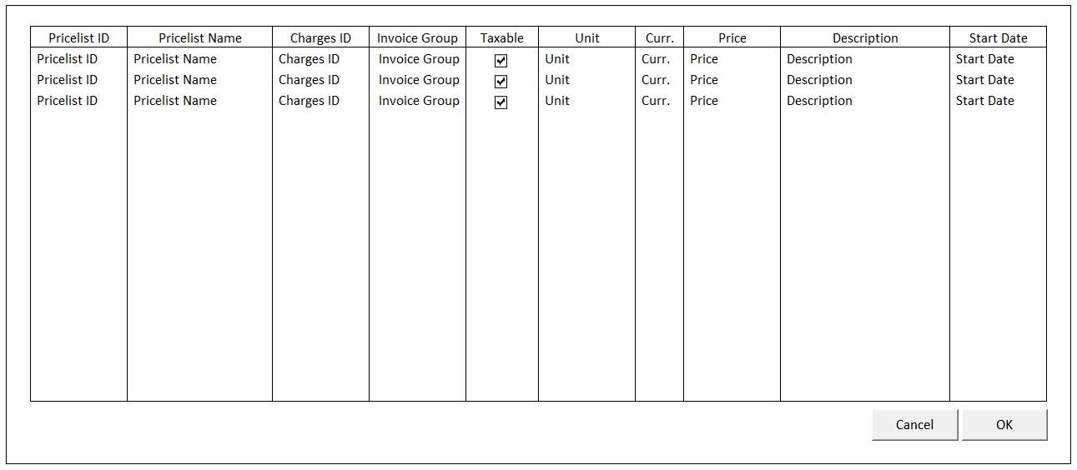

BUTTON DEFINITION
Button Name | Action
Cancel | Jalankan CANCEL PROCESS
OK | Jalankan PROCESS

INPUT PARAMETER
Parameter Name | Description
CCOMPANY_ID | Company Id
CPROPERTY_ID | Property Id
CSTATUS | 0 – All, 1 – Current, 2 – Next, 3 – History
CTAXABLE | 0 – All, 1 – Taxable, 2 – Non Taxable
CUSER_ID | User Id
CLOOKUP_DATE | Caller program’s specified date (will show pricelist according to this date)
CSLA_CALL_TYPE_ID | Call Type ID filter

OUTPUT PARAMETER
Parameter Name | Description
CCOMPANY_ID | Company Id
CPROPERTY_ID | Property Id
CPRICELIST_ID | Pricelist Id
CVALID_ID | Valid Id
CPRICELIST_NAME | Pricelist Name
CCHARGES_ID | Charges Id
CUNIT | Unit
CCURRENCY_CODE | Curr.
IPRICE | Price
CDESCRIPTION | Description
CSTART_DATE | Start Date
CINVGRP_CODE | Invoice Group
LTAXABLE | Taxable

INITIAL PROCESS
Test
- Load data from Input Parameter
- Set VAR_COMPANY_ID = Login User’s company id
- Set VAR_USER_ID = Login User ID
- Set VAR_LANGUAGE_ID = Login User’s Language ID
- Set VAR_STATUS = ‘0’

- Load Pricelist List
Jalankan RSP_HD_GET_PRICELIST_LIST dengan parameter, simpan hasil ke VAR_PRICELIST_LIST:
  - VAR_COMPANY_ID
  - CPROPERTY_ID
  - VAR_STATUS
  - VAR_LANGUAGE_ID
  - ‘’
  - CLOOKUP_DATE
  - CSLA_CALL_TYPE_ID
  - CTAXABLE

DISPLAY PROCESS

FIELD DEFINITION
Name | Field | Type | Validation
Pricelist Grid |  | Data: VAR_PRICELIST_LIST | Allow: -  ViewOnly  On Selected Changed,  Set VAR_SELECTED_PRICELIST = Selected row data  Load Pricelist Detail  Jalankan RSP_HD_GET_PRICELIST_DETAIL dengan parameter:  - VAR_COMPANY_ID  - CPROPERTY_ID  - VAR_SELECTED_PRICELIST.  CPRICELIST_ID  - VAR_SELECTED_PRICELIST.  CVALID_ID  - VAR_LANGUAGE_ID
Pricelist ID | CPRICELIST_ID | Textbox, Disabled
Pricelist Name | CPRICELIST_NAME | Textbox, Disabled
Charges ID | CCHARGES_ID | Textbox, Disabled
Invoice Group | CINVGRP_CODE | Textbox, Disabled
Taxable | LTAXABLE | Checkbox, Disabled
Unit | CUNIT | Textbox, Disabled
Curr. | CCURRENCY_CODE | Textbox, Disabled
Price | IPRICE | NumericTextbox, Disabled | Decimal Places = 2
Description | CDESCRIPTION | Textbox, Disabled
Valid ID | CVALID_ID | Hidden
Start Date | CSTART_DATE  Set DSTART_DATE = Convert from CSTART_DATE from format “YYYYMMDD”  Set Display:  DSTART_DATE | DatePicker, Disabled

CANCEL PROCESS

VALIDATION
Field | Condition | Validation Message

ACTION
- Close this Lookup

PROCESS

VALIDATION
Field | Condition | Validation Message

ACTION
- Close this Lookup
- Return VAR_SELECTED_PRICELIST ke form pemanggil

SELECT DATA PROCESS

VALIDATION
Field | Condition | Validation Message

ACTION
- Close this Lookup
- Return VAR_SELECTED_PRICELIST ke form pemanggil

HDL00300 – Public Location Lookup

USER INTERFACE

INITIAL VERSION
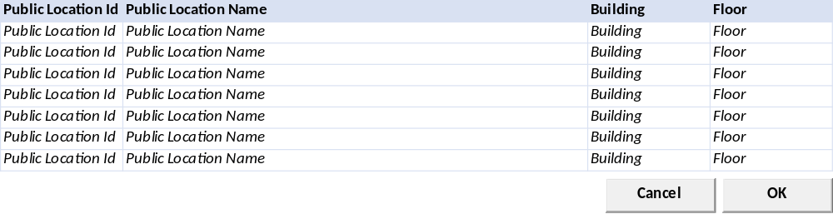

BUTTON DEFINITION
Button Name | Action
Cancel | Jalankan CANCEL PROCESS
OK | Jalankan PROCESS

INPUT PARAMETER
Parameter Name | Description
CCOMPANY_ID | Company Id
CPROPERTY_ID | Property Id
CUSER_ID | User Id
LACTIVE | 1
CBUILDING_ID | Building Id
CFLOOR_ID | Floor Id

OUTPUT PARAMETER
Parameter Name | Description
CCOMPANY_ID | Company Id
CPROPERTY_ID | Property Id
CPUBLIC_LOC_ID | Public Location Id
CPUBLIC_LOC_NAME | Public Location Name
CBUILDING_ID | Buidling Id
CBUILDING_NAME | Building Name
CFLOOR_ID | Floor Id
CFLOOR_NAME | Floor Name

INITIAL PROCESS
Test
- Load data from Input Parameter
- Set VAR_COMPANY_ID = Login User’s company id
- Set VAR_PROPERTY_ID = Selected Property Id
- Set VAR_USER_ID = Login User ID
- Set VAR_ACTIVE = ‘1’
- Set VAR_BUILDING_ID = Selected Building Id
- Set VAR_FLOOR_ID = Selected Floor Id

- Load Pricelist List
Jalankan RSP_HD_GET_PUBLIC_LOC_LIST dengan parameter, simpan hasil ke VAR_PUBLIC_LOC_LIST:
  - VAR_COMPANY_ID
  - CPROPERTY_ID
  - VAR_USER_ID
  - ‘1’
  - VAR_BUILDING_ID
  - VAR_FLOOR_ID

DISPLAY PROCESS

FIELD DEFINITION
Name | Field | Type | Validation
Public Loc Grid |  | Data: VAR_PUBLIC_LOC_LIST | Allow: -  ViewOnly  On Selected Changed,  Set VAR_SELECTED_PUBLIC_LOC = Selected row data  Load Public Loc Detail  Jalankan RSP_HD_GET_PUBLIC_LOC_DT dengan parameter:  - VAR_COMPANY_ID  - CPROPERTY_ID  - VAR_USER_ID  - VAR_SELECTED_PUBLIC_LOC
Public Location ID | CPUBLIC_LOC_ID | Textbox, Disabled
Public Location Name | CPUBLIC_LOC_NAME | Textbox, Disabled
Building Id | CBUILDING_ID | Textbox, Disabled
Building Name | CBUILDING_NAME | Textbox, Disabled
Floor Id | CFLOOR_ID | Textbox, Disabled
Floor Name | CFLOOR_NAME | Textbox, Disabled

CANCEL PROCESS

VALIDATION
Field | Condition | Validation Message

ACTION
- Close this Lookup

PROCESS

VALIDATION
Field | Condition | Validation Message

ACTION
- Close this Lookup
- Return VAR_SELECTED_PUBLIC_LOC ke form pemanggil

SELECT DATA PROCESS

VALIDATION
Field | Condition | Validation Message

ACTION
- Close this Lookup
- Return VAR_SELECTED_PUBLIC_LOC ke form pemanggil

HDL00400 – Asset Lookup

USER INTERFACE

INITIAL VERSION
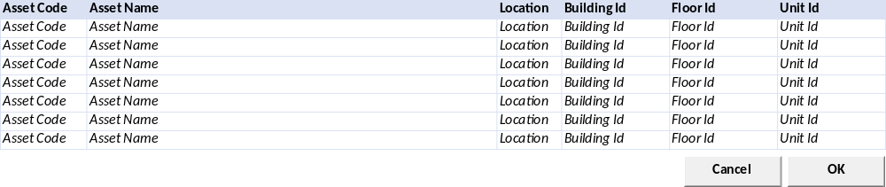

BUTTON DEFINITION
Button Name | Action
Cancel | Jalankan CANCEL PROCESS
OK | Jalankan PROCESS

INPUT PARAMETER
Parameter Name | Description
CCOMPANY_ID | Company Id
CPROPERTY_ID | Property Id
CUSER_ID | User Id
LACTIVE | 1
CBUILDING_ID | Building Id
CFLOOR_ID | Floor Id
CUNIT_ID | Unit Id
CFLOOR_ID | Floor Id
[CR01] CAREA_TYPE | Area Type

OUTPUT PARAMETER
Parameter Name | Description
CCOMPANY_ID | Company Id
CPROPERTY_ID | Property Id
CASSET_CODE | Asset Code
CASSET_NAME | Asset Name
CBUILDING_ID | Buidling Id
CBUILDING_NAME | Building Name
CFLOOR_ID | Floor Id
CFLOOR_NAME | Floor Name
CUNIT_ID | Unit Id
CUNIT_NAME | Unit Name
CLOCATION_ID | Location Id
CLOCATION_NAME | Location Name

INITIAL PROCESS
Test
- Load data from Input Parameter
- Set VAR_COMPANY_ID = Login User’s company id
- Set VAR_PROPERTY_ID = Selected Property Id
- Set VAR_BUILDING_ID = Selected Building Id
- Set VAR_FLOOR_ID = Selected Floor Id
- Set VAR_UNIT_ID = Selected Unit Id
- Set VAR_LOCATION_ID = Selected Location Id
- Set VAR_USER_ID = Login User ID
- Set VAR_AREA_TYPE = Selected Area Type

- Load Asset List
Jalankan RSP_HD_GET_ASSET_LOOKUP_LIST dengan parameter, simpan hasil ke VAR_ASSET_LIST:
  - VAR_COMPANY_ID
  - CPROPERTY_ID
  - VAR_BUILDING_ID
  - VAR_FLOOR_ID
  - VAR_UNIT_ID
  - VAR_LOCATION_ID
  - VAR_USER_ID
  - VAR_AREA_TYPE

DISPLAY PROCESS

FIELD DEFINITION
Name | Field | Type | Validation
Asset Grid |  | Data: VAR_ASSET_LIST | Allow: -  ViewOnly  On Selected Changed,  Set VAR_SELECTED_ASSET = Selected row data  Load Asset Detail  Jalankan RSP_HD_GET_ASSET_DT dengan parameter:  - VAR_COMPANY_ID  - CPROPERTY_ID  - VAR_USER_ID  - VAR_SELECTED_ASSET
Asset Code | CASSET_CODE | Textbox, Disabled
Asset Name | CASSET_NAME | Textbox, Disabled
Building Id | CBUILDING_ID | Textbox, Disabled
Building Name | CBUILDING_NAME | Textbox, Disabled
Floor Id | CFLOOR_ID | Textbox, Disabled
Floor Name | CFLOOR_NAME | Textbox, Disabled
Unit Id | CUNIT_ID | Textbox, Disabled
Unit Name | CUNIT_NAME | Textbox, Disabled
Location Id | CLOCATION_ID | Textbox, Disabled
Location Name | CLOCATION_NAME | Textbox, Disabled

CANCEL PROCESS

VALIDATION
Field | Condition | Validation Message

ACTION
- Close this Lookup

PROCESS

VALIDATION
Field | Condition | Validation Message

ACTION
- Close this Lookup
- Return VAR_SELECTED_PUBLIC_LOC ke form pemanggil

SELECT DATA PROCESS

VALIDATION
Field | Condition | Validation Message

ACTION
- Close this Lookup
- Return VAR_SELECTED_PUBLIC_LOC ke form pemanggil

HDL00500 – Task Lookup

USER INTERFACE

INITIAL VERSION
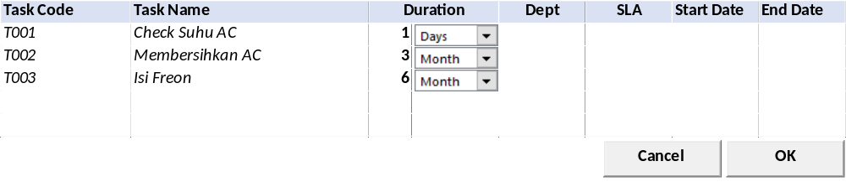

BUTTON DEFINITION
Button Name | Action
Cancel | Jalankan CANCEL PROCESS
OK | Jalankan PROCESS

INPUT PARAMETER
Parameter Name | Description
CCOMPANY_ID | Company Id
CPROPERTY_ID | Property Id
CUSER_ID | User Id

OUTPUT PARAMETER
Parameter Name | Description
CCOMPANY_ID | Company Id
CPROPERTY_ID | Property Id
CTASK_CODE | Task Code
CTASK_NAME | Task Name
IDURATION_TIME | Duration Time
CDURATION_TYPE_DESCR | Duration Type
CDEPT_NAME | Dept
CCALL_TYPE_NAME | SLA
CSTART_DATE | Start Date
CEND_DATE | End Date

INITIAL PROCESS
Test
- Load data from Input Parameter
- Set VAR_COMPANY_ID = Login User’s company id
- Set VAR_PROPERTY_ID = Selected Property Id
- Set VAR_USER_ID = Login User ID

- Load Task List
Jalankan RSP_HD_GET_TASK_DT_LIST dengan parameter, simpan hasil ke VAR_TASK_LIST:
  - VAR_COMPANY_ID
  - CPROPERTY_ID
  - VAR_USER_ID
  - ‘’

DISPLAY PROCESS

FIELD DEFINITION
Name | Field | Type | Validation
Task Code | CTASK_CODE | Textbox, Disabled
Task Name | CTASK_NAME | Textbox, Disabled
Duration Time | IDURATION_TIME | Textbox, Disabled
Duration Type | CDURATION_TYPE_DESCR | Textbox, Disabled
Dept | CDEPT_NAME | Textbox, Disabled
SLA | CCALL_TYPE_NAME | Textbox, Disabled
Start Date | CSTART_DATE | Textbox, Disabled
End Date | CEND_DATE | Textbox, Disabled

CANCEL PROCESS

VALIDATION
Field | Condition | Validation Message

ACTION
- Close this Lookup

PROCESS

VALIDATION
Field | Condition | Validation Message

ACTION
- Close this Lookup
- Return VAR_SELECTED_TASK ke form pemanggil

SELECT DATA PROCESS

VALIDATION
Field | Condition | Validation Message

ACTION
- Close this Lookup
- Return VAR_SELECTED_TASK ke form pemanggil

HDL00600 – Task Checlist Lookup

USER INTERFACE

INITIAL VERSION
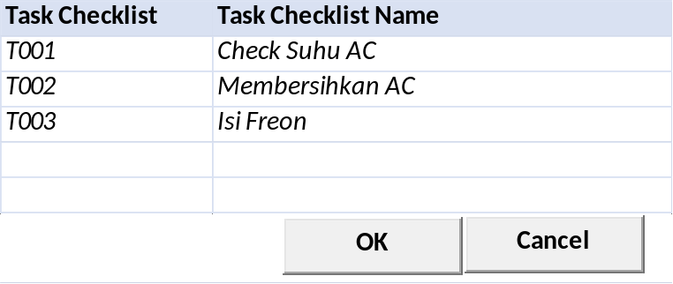

BUTTON DEFINITION
Button Name | Action
Cancel | Jalankan CANCEL PROCESS
OK | Jalankan PROCESS

INPUT PARAMETER
Parameter Name | Description
CCOMPANY_ID | Company Id
CPROPERTY_ID | Property Id
CUSER_ID | User Id

OUTPUT PARAMETER
Parameter Name | Description
CCOMPANY_ID | Company Id
CPROPERTY_ID | Property Id
CTASK_CHECKLIST_CODE | Task Checklist Code
CTASK_CHECKLIST_NAME | Task Checklist Name

INITIAL PROCESS
Test
- Load data from Input Parameter
- Set VAR_COMPANY_ID = Login User’s company id
- Set VAR_PROPERTY_ID = Selected Property Id
- Set VAR_USER_ID = Login User ID

- Load Task List
Jalankan RSP_HD_GET_TASK_CHECKLIST_LIST dengan parameter, simpan hasil ke VAR_TASK_LIST:
  - VAR_COMPANY_ID
  - CPROPERTY_ID
  - VAR_USER_ID

DISPLAY PROCESS

FIELD DEFINITION
Name | Field | Type | Validation
Task Checklist Code | CTASK_CHECKLIST_ID | Textbox, Disabled
Task Checklist Name | CTASK_CHECKLIST_NAME | Textbox, Disabled

CANCEL PROCESS

VALIDATION
Field | Condition | Validation Message

ACTION
- Close this Lookup

PROCESS

VALIDATION
Field | Condition | Validation Message

ACTION
- Close this Lookup
- Return VAR_SELECTED_TASK_CHECKLIST ke form pemanggil

SELECT DATA PROCESS

VALIDATION
Field | Condition | Validation Message

ACTION
- Close this Lookup
- Return VAR_SELECTED_TASK_CHECKLIST ke form pemanggil

CR List
No | Note | Date
CR01  RE, 11 Feb 2025 | - Menambahkan input parameter untuk lookup Asset

